PASSIVE COOLING FOR HOME

A PROJECT REPORT

Submitted by
KARTHIKEYAN. V SIVA. A SREENITHISH. M. K SHOWTHREE. R. R

in partial fulfillment for the award of the degree of

BACHELOR OF ENGINEERING
IN

MECHANICAL ENGINEERING

KNOWLEDGE INSTITUTE OF TECHNOLOGY

ANNA UNIVERSITY:: CHENNAI 600 025

DEC 2025

ANNA UNIVERSITY: CHENNAI 600 025

BONAFIDE CERTIFICATE

Certified that this project report “Passive Cooling For Home” is the bonafide work of “KARTHIKEYAN. V, SIVA. A, SREENITHISH. M. K, SHOWTHREE. R. R” who carried out the project work under my supervision.

SIGNATURE SIGNATURE

Dr. K.S. PRABHAKARAN., M.E., Ph.D. Prof. A. GAJENDRAN.,B.E.,M.E.
HEAD OF THE DEPARTMENT SUPERVISOR
PROFESSOR ASSISTANT PROFESSOR
DEPARTMENT OF MEHANICAL DEPARTMENT OF
ENGINEERING MECHANICAL ENGINEERING

KNOWLEDGE INSTITUTE OF KNOWLEDGE INSTITUTE OF
TECHNOLOGY TECHNOLOGY

KIOT CAMPUS KIOT CAMPUS
KAKAPALAYAM (PO) KAKAPALAYAM (PO)
SALEM – 637504 SALEM - 637504

ABSTRACT
The Passive cooling is an energy-efficient technique used to maintain indoor thermal comfort without relying on mechanical systems such as air conditioners or fans. This project focuses on the design and implementation of a Passive Cooling System for a Residential Home, utilizing natural principles such as ventilation, heat dissipation, shading, and thermal mass. The system reduces indoor temperature by minimizing heat gain and enhancing heat removal using architectural and material-based strategies. The proposed model demonstrates reduced energy consumption, improved thermal comfort, and environmental sustainability, making it suitable for tropical and subtropical climates. By minimizing heat gain through proper insulation, reflective roofing, shading elements, and optimized window placement, and by enhancing heat removal through cross-ventilation and stack effect, the proposed system significantly reduces indoor heat accumulation. Materials with high thermal mass are incorporated to absorb excess heat during daytime and release it during cooler nighttime conditions, improving overall thermal stability. The experimental model and analysis demonstrate a noticeable reduction in indoor temperature when compared to conventional building designs, leading to lower energy consumption and reduced dependence on mechanical cooling systems. In addition to improving thermal comfort, the system contributes to environmental sustainability by reducing carbon emissions and operational costs.
Keywords: Passive Cooling, Natural Ventilation, Thermal Comfort, Energy Efficiency, Sustainable Housing.
TABLE OF CONTENTS

CHAPTER NO. | TITLE | PAGE NO.
 | ABSTRACT | iii
 | LIST OF TABLES | vii
 | LIST OF FIGURES | viii
 | LIST OF SYMBOLS & ABBREVIATIONS | ix
1. | INTRODUCTION | 7
 | 1.1 Methodology | 8
2. | LITERATURE REVIEW | 9
3. | COMPONENTS, SPECIFICATION AND DESCRIPTION | 10
 | 3.1 Components | 11
 | 3.2 Component Description | 12
 | 3.2.1 ESP32 BOARD | 12
 | 3.2.2 RTC DS3231 | 13
 | 3.2.3 SD CARD MODULE | 14
 | 3.2.4 DS18B20 | 15
 | 3.2.5 Jumper wires | 16
 | 3.2.6 SD Card | 17
 | 3.3.7 Resistor | 17

CHAPTER NO. |  | TITLE | PAGE NO.
4 |  | WORKING PRINCIPLE | 18
 |  | 4.1 Heat gain reduction stage | 19
 |  | 4.2 Natural airflow and cooling stage | 19
 |  | 4.3 Temperature regulation and comfort maintenance | 20
 |  | 4.4 System Operation Flow | 20
 |  | 4.5 Working Logic Interpretation | 21
 |  | 4.6 Summary | 21
5 |  | COST ESTIMATION | 22
6 |  | SCOPE OF FUTURE WORK | 23
 |  | 6.1 Advantages | 23
 |  | 6.2 Applications | 23
9  10 |  | CONCLUSION  REFERENCES | 24  25

LIST OF TABLES

Table No. | Title | Page No.
Table 3.1 | List of Components | 11
Table 4.4 | System Operation Flow | 20
Table 5.1 | Cost Estimation | 22

CHAPTER -1
  - INTRODUCTION

In the rapid increase in global energy demand and rising ambient temperatures, conventional air-conditioning systems have become a major consumer of electricity and a significant contributor to environmental pollution. In residential buildings, cooling loads account for a substantial portion of total energy consumption, leading to higher operational costs and increased carbon emissions.
Passive cooling provides a sustainable and energy-efficient alternative by utilizing natural heat transfer mechanisms such as conduction, convection, and radiation to regulate indoor thermal conditions. This approach emphasizes intelligent building design, including proper orientation, selection of appropriate construction materials, effective shading techniques, optimized ventilation paths, and the use of evaporative cooling methods to minimize heat gain and enhance heat dissipation.
The primary objective of this project is to design and develop a passive cooling residential home model capable of maintaining acceptable indoor thermal comfort without the use of external power sources. By eliminating dependence on mechanical cooling systems, the proposed model proves to be cost-effective, environmentally friendly, and suitable for sustainable housing applications, particularly in hot and humid climatic regions.
Passive cooling is a natural and energy-saving method that reduces indoor temperature without using electrical power. It works by using natural heat transfer processes such as conduction, convection, and radiation. Proper building orientation, suitable materials, shading, natural ventilation, and evaporative cooling help in reducing heat inside the house.
    - METHODOLOGY

In this project, a passive cooling system is designed and evaluated using the following systematic methodology. The main aim of this methodology is to reduce indoor temperature naturally without using electrical energy.
- Climate Analysis
The local climatic conditions are studied to understand temperature variations, solar radiation, humidity, and prevailing wind directions. This analysis helps in selecting appropriate passive cooling strategies suitable for the region.
- Building Orientation
The building is oriented to minimize exposure to direct solar radiation, especially during peak daytime hours. Longer walls are aligned along the north–south direction to reduce heat gain and improve thermal comfort.
- Material Selection
Materials with low thermal conductivity and high thermal mass are chosen to reduce heat transfer. Insulating materials such as cardboard and thermocol are used in the model to represent real-life materials like brick, mud, and concrete that store heat and release it slowly.
- Ventilation Planning
Natural ventilation techniques such as cross-ventilation and the stack effect are incorporated. Openings are placed strategically at different heights to allow hot air to escape and fresh air to enter, improving indoor air circulation.
- Shading Techniques
The Shading elements such as roof overhangs, fins, louvers, and external shades are added to block direct sunlight from entering the building. These features help reduce indoor temperature and glare.

CHAPTER- 2 LITERATURE REVIEW
- Givoni (1994)
The author studied passive cooling strategies for residential buildings in hot climatic regions. The research focused on natural ventilation, building orientation, and the use of thermal mass to reduce indoor temperatures. The study demonstrated that cross-ventilation and stack effect significantly improve indoor air circulation, resulting in a reduction of indoor temperature by 2–5°C. The work proved that passive cooling techniques can effectively replace mechanical cooling systems in residential homes.
- Santamouris and Asimakopoulos (2007)
The authors developed a comprehensive analysis of passive cooling techniques such as solar shading, reflective roofing, and natural airflow control in residential buildings. Their study included both experimental and simulation-based evaluations. The results showed that the use of external shading devices and high-reflectivity materials reduced cooling energy demand by up to 30%. The research confirmed that passive cooling methods significantly enhance thermal comfort while reducing energy consumption.
- Ali and Al-Alawi (2011)
The researchers investigated the role of thermal mass materials in passive cooling of residential buildings. Materials such as brick, stone, and clay were analyzed for their heat absorption and release characteristics. The study demonstrated that high thermal mass walls absorb heat during the daytime and release it during nighttime, thereby maintaining stable indoor temperatures. The findings showed improved thermal comfort and reduced temperature fluctuations inside homes.
- O’Neill and Cao (2012)
The authors examined the effectiveness of solar control methods such as roof overhangs, louvers, and vertical fins in residential buildings. Using experimental analysis, the study showed that proper shading reduced direct solar radiation entering buildings by more than 40%. The results confirmed that shading devices play a critical role in minimizing heat gain and improving indoor thermal comfort in passive cooling systems.
CHAPTER 3
COMPONENTS SPECIFICATION AND DESCRIPTION
  - COMPONENTS
The list of components used are,

S.NO. | COMPONENTS | QUANTITY
1 | ESP32 Board | 1
2 | RTC DS3231 | 1
3 | SD Card Module | 1
4 | DS18B20 | 2
5 | Jumper wires | As Per Recruitment
6 | SD Card | 1
7 | Resistor | 2
8 | Cardboard | As Per Recruitment
Table 3.1 List of Components

  - COMPONENTS DESCRIPTION

    - ESP32 Board

The The ESP32 board is a low-power, high-performance microcontroller developed by Espressif Systems, widely used in Internet of Things (IoT) and embedded system applications. It integrates Wi-Fi and Bluetooth capabilities on a single chip, making it suitable for smart home and automation projects.
The ESP32 operates with a dual-core 32-bit processor and supports a clock frequency of up to 240 MHz. It provides multiple GPIO pins that can be configured for digital input/output, analog-to-digital conversion (ADC), pulse-width modulation (PWM), UART, SPI, and I²C communication. These features allow the ESP32 to interface easily with various sensors, actuators, and external modules.
One of the key advantages of the ESP32 board is its low power consumption, which includes several sleep modes such as deep sleep and light sleep. This makes it ideal for energy-efficient systems. The board also supports programming through the Arduino IDE, MicroPython, and ESP-IDF, offering flexibility for developers.
In this project, the ESP32 board acts as the main control unit. It is responsible for collecting data from connected sensors, processing the information, and controlling output devices according to the system requirements. Its built-in wireless communication enables remote monitoring and control, enhancing the overall functionality of the system.

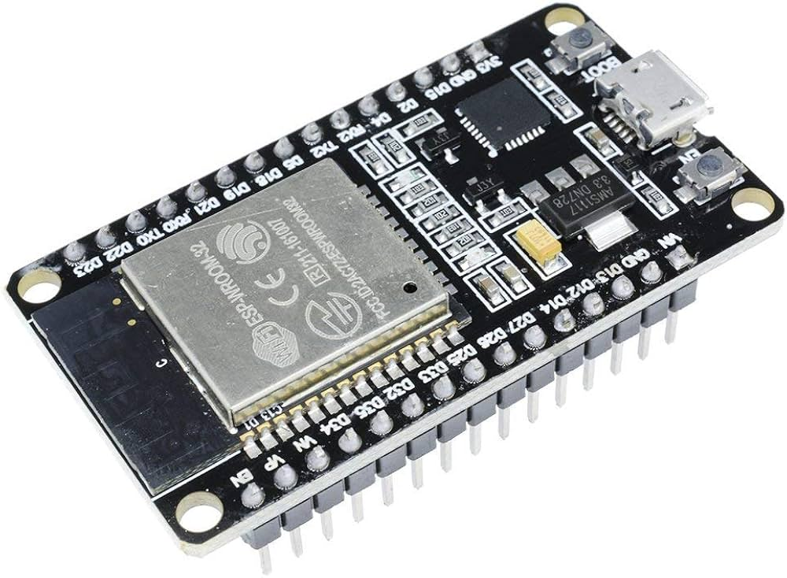

Figure 3.1 –ESP32 Board

    - RTC DS3231

The The DS3231 is a high-precision Real Time Clock (RTC) module used to keep accurate time and date information in embedded systems. It is widely preferred due to its high accuracy and reliability compared to standard RTC modules.
The DS3231 uses a temperature-compensated crystal oscillator (TCXO), which minimizes time drift caused by temperature variations. This allows the module to maintain accurate time even over long periods. It operates using the I²C communication protocol, making it easy to interface with microcontrollers such as the ESP32.
The RTC module provides time data including seconds, minutes, hours, day, date, month, and year. It also includes a backup coin-cell battery, which ensures continuous timekeeping even when the main power supply is disconnected.
In this project, the DS3231 RTC module is used to maintain real-time clock information for scheduling and time-based operations. It allows the system to perform actions at specific times and ensures accurate timestamping of data, improving the reliability and automation of the overall system.

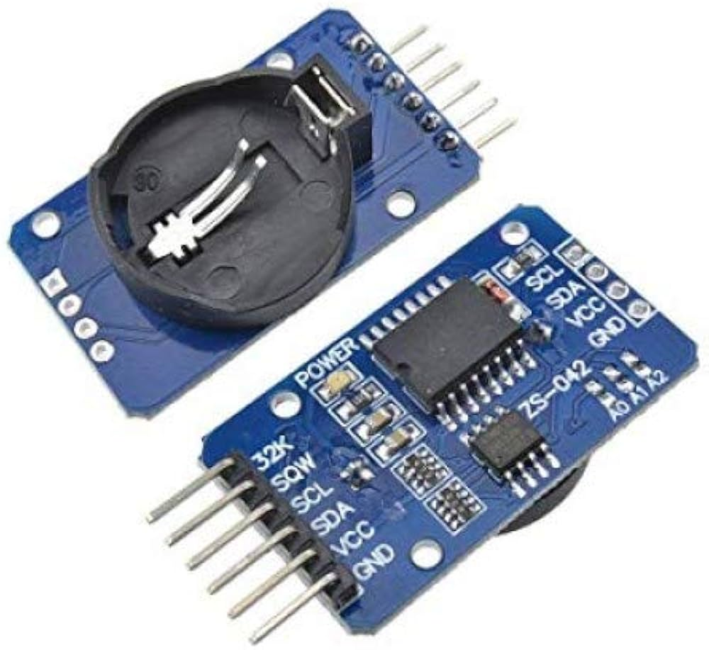

Figure 3.2 –RTC DS3231
    - SD Card Module

The SD Card Module provides external storage for embedded systems, allowing large amounts of data to be saved securely. It communicates with the ESP32 via the SPI protocol, ensuring fast and reliable data transfer. The module supports standard SD and microSD cards and operates at 3.3 V, compatible with the ESP32.
In this project, the SD Card Module is used to store real-time sensor data along with timestamps from the RTC module. This enables long-term data logging, offline analysis, and improved system reliability.

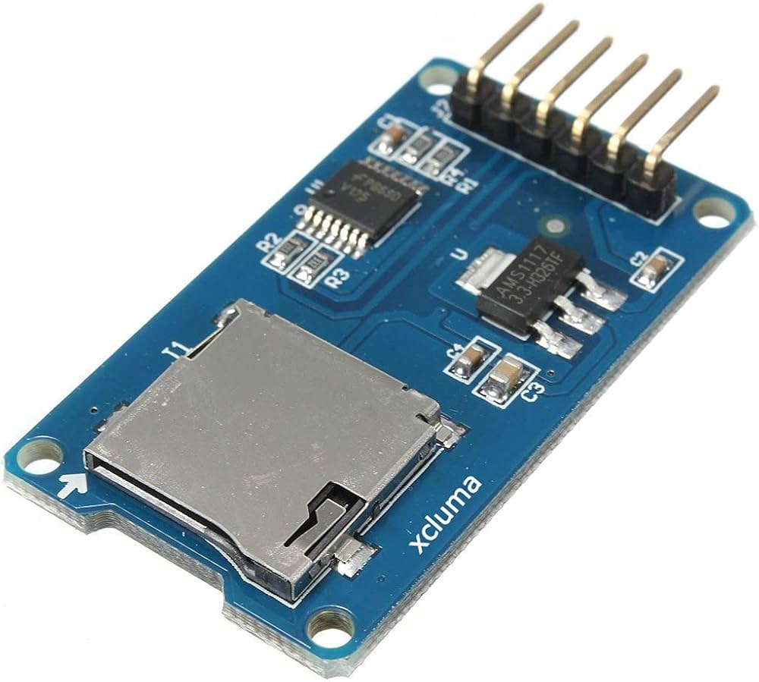

Figure 3.3 – SD Card Module

    - DS18B20

The DS18B20 is a digital temperature sensor widely used in embedded systems for precise temperature monitoring. It communicates with the microcontroller using the 1-Wire protocol, which allows multiple sensors to be connected on a single data line, simplifying wiring and system design. The sensor provides temperature readings with a resolution of up to 12 bits and operates over a voltage range of 3.0–5.5 V. Its reliability and ease of interfacing make it ideal for both indoor and outdoor applications, including environmental monitoring and industrial systems.
In this project, the DS18B20 is used to measure real-time temperature. The sensor sends the readings to the ESP32, which processes the data and logs it to the SD card along with timestamps from the RTC module. This enables accurate temperature tracking, long-term data logging, and system monitoring for analysis and control purposes.

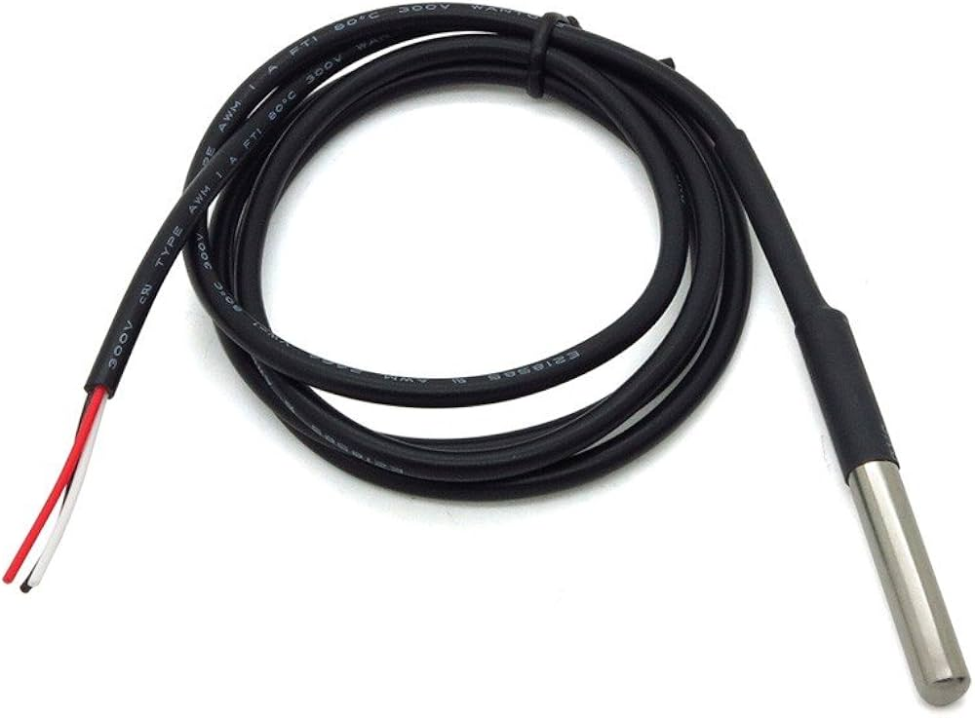

Figure 3.4 – DS18B20

    - Jumper Wires

The Jumper wires are flexible, insulated wires used to make connections between components on a breadboard or between modules and microcontrollers like the ESP32. They come in male-to-male, male-to-female, and female-to-female types to suit different connection needs.
In this project, jumper wires are used to connect the ESP32 with sensors, the SD card module, and the RTC, enabling proper signal transmission and power supply. Their use ensures a neat, reliable, and easily modifiable circuit setup

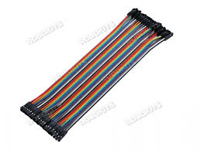

Figure 3.5 – Jumper Wires

    - SD Card

An SD Card is a removable storage device used to store large amounts of data in digital systems. It provides non-volatile memory, ensuring that data is retained even when the power is turned off.
In this project, the SD Card works with the SD Card Module to store real-time sensor data and timestamps from the RTC. This allows long-term data logging, offline access, and easy transfer of recorded information for analysis.

Figure 3.6 – SD Card

    - Resistor

A resistor is a passive electrical component that limits or regulates the flow of electric current in a circuit. It helps protect sensitive components and ensures proper voltage levels across devices.
In this project, resistors are used with sensors and modules, such as pull-up resistors for the DS18B20 and current-limiting resistors for LEDs, to ensure accurate readings and safe operation of the circuit.

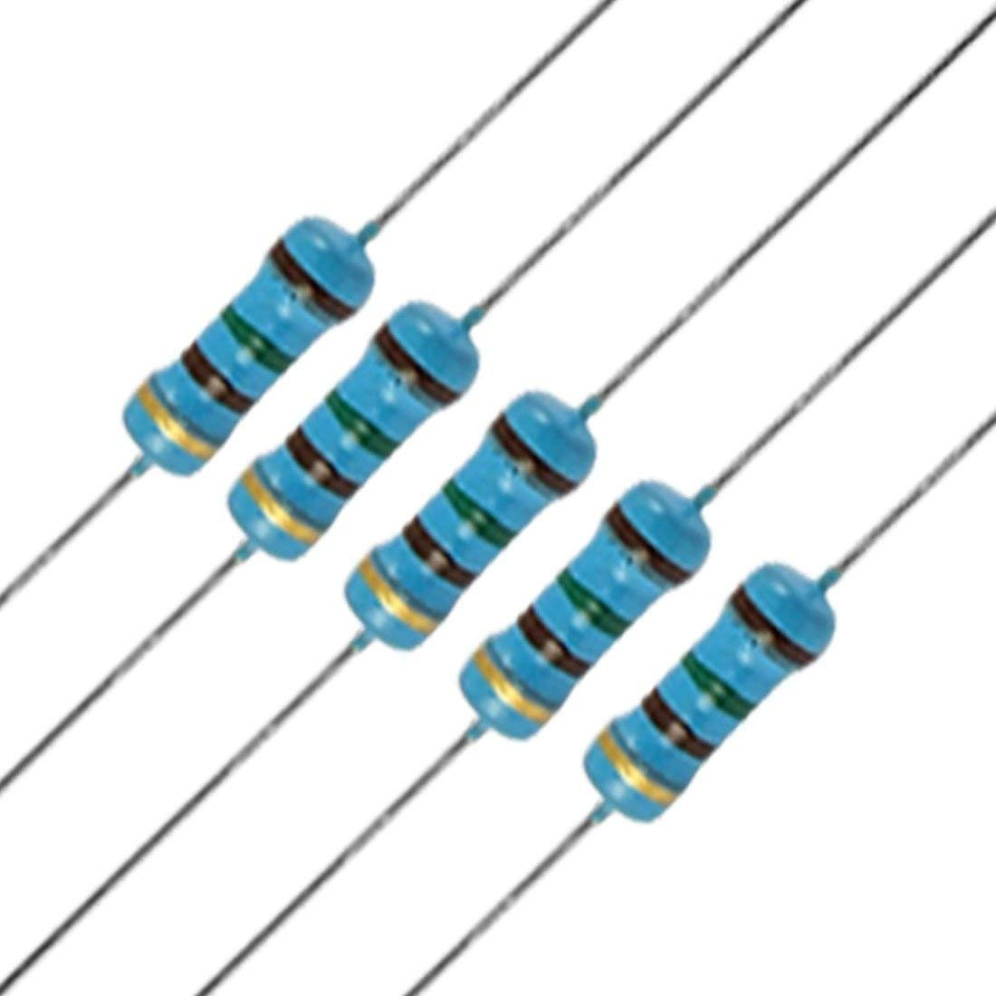

Figure 3.7 – 4.7k Resistor

CHAPTER 4 WORKING PRINCIPLE
The Passive Cooling System for Homes operates as an integrated design approach to maintain indoor thermal comfort without using mechanical cooling devices. The system combines architectural elements, natural ventilation, shading, thermal mass, and optional evaporative cooling components to reduce indoor temperatures effectively.
The working principle is based on three major operational stages:
(1) Heat Gain Reduction, (2) Natural Airflow and Cooling, and (3) Temperature Regulation and Comfort Maintenance.

  - HEAT GAIN REDUCTION STAGE

- Building Orientation: Optimized to reduce sunlight on walls/windows.
- Reflective Surfaces: Roofs and walls with high-albedo coatings reflect solar radiation.
- Shading Devices: Overhangs, louvers, and fins block direct sun.
- Thermal Mass Materials: Brick, clay, or concrete absorb heat and reduce temperature spikes.
- Window Glazing: Double or low-emissivity (Low-E) glass reduces solar heat gain.
- Vegetative Shading: Trees, green walls, or vertical gardens provide natural cooling.
- Roof Treatments: Cool roofs or light-colored roofing materials minimize heat absorption.
- Ventilated Facades: Air gaps in walls/facades reduce heat transfer indoors.
  - NATURAL AIRFLOW AND COOLING STAGE

Once heat gain is minimized, the system uses natural airflow to remove warm air and introduce cooler air:
- Ventilation Openings:

  - Strategically placed windows, vents, and low-level air inlets allow cool air to enter.
  - High-level vents or chimneys enable warm air to rise and escape via the stack effect.
  - Adjustable louvers or shutters control airflow direction and intensity

- Evaporative Cooling :

  - Water trays, wet pads, or small ponds near air inlets absorb heat as water evaporates, lowering incoming air temperature.
  - Indoor plants and green walls can increase humidity and slightly reduce indoor temperature.
  - Mist or fogging systems near windows enhance local cooling in dry climates

- Cross-Ventilation:

  - Air flows horizontally through the house, cooling internal spaces while maintaining fresh air circulation.
  - Open-plan layouts and internal corridors improve airflow efficiency
  - Placement of furniture and partitions avoids blocking air paths, ensuring smooth movement.

  - TEMPERATURE REGULATION AND COMFORT MAINTENANCE

The system continuously maintains a comfortable indoor climate by balancing heat absorption, shading, and natural airflow:
- During daytime, thermal mass absorbs heat while shading prevents overheating.
- Hot air rises and exits through roof vents or chimneys, pulling cooler air from outside.
- Evaporative cooling elements supplement airflow in hot, dry climates.
- Indoor temperatures remain stable, reducing reliance on mechanical air-conditioning systems.

  - SYSTEM OPERATION FLOW

Step No. | Operation Description
1 | Sunlight strikes the building; shading devices reduce heat gain.
2 | Thermal mass absorbs residual heat from walls and floors
3 | Cool air enters through low-level openings.
4 | Warm air rises and exits through roof vents or chimneys.
5 | Evaporative cooling further reduces air temperature (if implemented).
6 | Indoor temperature stabilizes, maintaining thermal comfort.
7 | Inspection data is logged; the system resets for the next bottle.

  - WORKING LOGIC INTERPRETATION

The system’s operation follows a natural cyclic logic similar to PDCA:

    - Plan: Design building orientation, thermal mass, ventilation, and shading for optimal passive cooling.
    - Check: Observe indoor temperature and airflow patterns.
    - Act: Adjust window sizes, vent positions, or shading devices to improve cooling efficiency.

  - SUMMARY
The Passive Cooling System for Homes functions through a fully natural workflow integrating heat gain reduction, strategic ventilation, thermal mass, and optional evaporative cooling. By combining architectural design with natural physical principles:
High accuracy
    - Mechanical cooling use is minimized, saving energy and cost.
    - Temperature fluctuations are reduced, stabilizing indoor climate.

The overall working principle demonstrates an eco-friendly, low-cost, and sustainable approach to residential cooling, providing reliable indoor comfort without electricity.

CHAPTER 5 COST ESTIMATION
S.NO. | NAME OF THE COMPONENT | QUANTITY | PRICE (Rs.)
1 | ESP32 Board | 1 | 450
2 | RTC DS3231 | 1 | 200
3 | SD Card Module | 1 | 150
4 | DS18B20 | 2 | 300
5 | Jumper wires | 2 set | 60
6 | SD Card | 1 | 350
7 | Resistor | 2 | 16
8 | Cardboard | 7 | 500
 |  | Total | 2020

CHAPTER 6

SCOPE OF FUTURE WORK

- Advanced passive cooling materials such as phase change materials (PCM) can be incorporated to improve heat storage and temperature regulation.

- Integration of smart ventilation designs and adaptive window systems can enhance airflow efficiency under varying climatic conditions.

- Passive cooling performance can be optimized using computer-based thermal simulations for different building layouts and climates.

- Combination of passive cooling with low-power monitoring systems can enable better evaluation of indoor thermal comfort.

- By Large-scale implementation in residential housing projects can significantly reduce construction and operational costs while improving energy efficiency.

  - ADVANTAGES
    - No electrical energy is required for cooling operation.
    - Environmentally friendly and sustainable cooling solution.
    - Low installation and maintenance cost compared to conventional cooling systems.
    - Improves indoor thermal comfort naturally.
    - Reduces dependency on air-conditioning and fossil fuel energy.
    - Suitable for various residential building designs and climates.

6.2 APPLICATIONS
    - Residential houses and apartments
    - Low-cost and affordable housing projects
    - Eco-friendly and green building constructions
    - Rural housing and smart village developments
    - Schools, hostels, and community buildings

CONCLUSION

Thus, the design and development of a Passive Cooling System for Residential Homes has been successfully completed, fulfilling all the objectives stated at the beginning of the project with satisfactory results. In this project, conventional mechanical cooling methods were replaced by an energy-efficient passive cooling approach that utilizes natural principles such as ventilation, thermal mass, shading, and heat dissipation. The system effectively reduces indoor temperature by minimizing heat gain and enhancing natural airflow, thereby improving indoor thermal comfort without the use of electrical power. The developed model integrates key passive components including proper building orientation, ventilation openings, roof vents, shading devices, thermal mass materials, and optional evaporative cooling elements. These components work together to regulate indoor temperature throughout the day and night. The system demonstrated stable thermal performance under typical climatic conditions and showed a noticeable reduction in indoor heat accumulation when compared to conventional housing designs. This project proves that passive cooling is a cost-effective, sustainable, and environmentally friendly alternative to air-conditioning systems, especially in tropical and subtropical regions. The successful implementation of this model highlights the potential for large-scale adoption in residential buildings, low-cost housing projects, and eco-friendly construction. Hence, the developed passive cooling system represents an important step toward energy conservation, reduced carbon footprint, and sustainable living in modern residential environments.

REFERENCES
- R. A. Ali, N. A. Megahed, M. M. Shahda, and A. M. Hassan, “Natural ventilation as a passive cooling strategy for multi-story buildings: Analytic vertical skycourt formations,” *City, Territory and Architecture*, vol. 10, art. no. 28, 2023. doi:10.1186/s40410-023-00212-6. :contentReference[oaicite:0]{index=0}

- N. Y. Andrew, J. N. Uwa, and A. Odion, “Passive cooling techniques in historical building versus contemporary biomimic concepts: An overview,” *American Journal of Civil Engineering and Architecture*, vol. 11, no. 4, pp. 111–119, 2023. doi:10.12691/ajcea-11-4-2. :contentReference[oaicite:1]{index=1}

- M. Ghamari, C. H. See, D. Hughes, T. Mallick, K. S. Reddy, K. Patchigolla, and S. Sundaram, “Advancing sustainable building through passive cooling with phase change materials: A comprehensive literature review,” *Energy and Buildings*, vol. 312, 114164, 2024. doi:10.1016/j.enbuild.2024.114164. :contentReference[oaicite:2]{index=2}

- L. Iskandar, E. Bay-Sahin, A. Martinez-Molina, and S. Toker Beeson, “Evaluation of passive cooling through natural ventilation strategies in historic residential buildings using CFD simulations,” *Energy and Buildings*, vol. 308, 114005, 2024. doi:10.1016/j.enbuild.2024.114005. :contentReference[oaicite:3]{index=3}

- L. M. Obeidat, J. R. Jones, D. M. Mahaftha, A. I. Amhamed, and O. F. Alrebei, “Optimizing indoor air quality and energy efficiency in multifamily residences: Advanced passive pipe system parametrics study,” *International Journal of Environmental Science and Technology*, vol. 21, pp. 10003–10026, 2024. doi:10.1007/s13762-024-05624-6. :contentReference[oaicite:4]{index=4}

- B. Givoni, “Passive cooling of buildings by natural ventilation and radiation,” Energy and Buildings, vol. 2, no. 3, pp. 189–197, 1978. doi:10.1016/0378-7788(78)90006-2.
- M. Santamouris and D. Kolokotsa, “Passive cooling dissipation techniques for buildings and other structures: The state of the art,” Energy and Buildings, vol. 57, pp. 74–94, 2013. doi:10.1016/j.enbuild.2012.11.002.
- S. Gupta, M. Khare, and R. Goyal, “Passive cooling strategies for buildings in composite climates of India,” Building and Environment, vol. 66, pp. 130–142, 2013. doi:10.1016/j.buildenv.2013.04.018.
- A. Zaki, S. R. Rijal, and M. Shukuya, “Passive cooling design strategies for residential buildings in hot and humid climates,” Journal of Asian Architecture and Building Engineering, vol. 16, no. 2, pp. 353–360, 2017. doi:10.3130/jaabe.16.353.
- P. La Roche, “Carbon-neutral architectural design through passive cooling,” Journal of Green Building, vol. 7, no. 4, pp. 23–39, 2012. doi:10.3992/jgb.7.4.23.
- F. Nicol and M. Humphreys, “Adaptive thermal comfort and sustainable thermal standards for buildings,” Energy and Buildings, vol. 34, no. 6, pp. 563–572, 2002. doi:10.1016/S0378-7788(02)00006-3.
- M. Taleghani, M. Tenpierik, and A. van den Dobbelsteen, “Energy performance and thermal comfort of courtyard buildings in hot climates,” Energy and Buildings, vol. 55, pp. 173–184, 2012. doi:10.1016/j.enbuild.2012.08.013.
- A. Al-Shaibani, A. Al-Habaibeh, and D. G. Anderson, “Evaluation of passive cooling techniques for residential buildings in hot climates,” Renewable Energy, vol. 95, pp. 324–337, 2016. doi:10.1016/j.renene.2016.04.023.
- J. Yang and S. Li, “Effect of building envelope design on passive cooling performance of residential buildings,” Sustainable Cities and Society, vol. 28, pp. 230–238, 2017. doi:10.1016/j.scs.2016.09.010.
- H. E. Akbari and R. Levinson, “Evolution of cool-roof standards in the U.S.,” Advances in Building Energy Research, vol. 2, no. 1, pp. 1–32, 2008. doi:10.3763/aber.2008.0201.
- M. De Dear and G. Brager, “Developing an adaptive model of thermal comfort and preference,” ASHRAE Transactions, vol. 104, no. 1, pp. 145–167, 1998.
- A. Bahadori, “Passive cooling systems in Iranian architecture,” Scientific American, vol. 238, no. 2, pp. 144–154, 1978.
- S. Kubota, M. Toe, and T. Ossen, “Field investigation of passive cooling strategies in residential buildings in hot–humid climates,” Building and Environment, vol. 44, no. 4, pp. 773–783, 2009. doi:10.1016/j.buildenv.2008.06.009.
- R. Kumar and S. Kaushik, “Performance evaluation of green roof and shading for passive cooling,” Energy and Buildings, vol. 44, pp. 215–224, 2012. doi:10.1016/j.enbuild.2011.10.020.
- M. Santamouris, “Cooling the buildings – past, present and future,” Energy and Buildings, vol. 128, pp. 617–638, 2016. doi:10.1016/j.enbuild.2016.07.034.

